The Chairperson
IEC-NRI Medical College & General Hospital,
Chinakakani, Guntur (Dist), AP.

Project Title :

Department :
Place of Study :
Purpose of the Study :
Principal Investigator :
Name :
Affiliation :
Email :

Guide / Co-investigators :
- Name :
Affiliation :

- Name :
Affiliation :

Duration of study :
Sponsors (if any) :
Approval from any other Ethics / Regulatory Committee (if required):

I shall follow the Good Clinical Practice guidelines and approved protocol in conducting the research project. Further I/we declare that any sort of inclusion of text or pictorial material which amounts to Plagiarism will be avoided.

Signature of Guide Signature of the Investigator(s)
The proposal has been verified as per the requirement mentioned in the information broacher and forwarded to the IEC, NRIAS for approval. Synopsis of the project, Informed consent form, Case record form and Study flow chart are enclosed.

Signature of the HOD
(With full name and rubber stamp)

(For IEC office use) Proposal No. Date:

SYNOPSIS
Title :
Principal Investigator :
Department & Institution :

Introduction (brief):

Aims & Objectives:
Review of literature (brief):

Methodology:

Study design:
Study setting:

Study population:
Inclusion criteria:

Exclusion criteria:

Method of Collection of Data:
Statistical Analysis:

References (5 to 6):

STUDY FLOW CHART

Title :
Principal Investigator :

Department & Institution :

Protocol Preparation & submission for IEC Clearance

Data Collection
(Selection of patients as per the inclusion-exclusion criteria)

Data Entry & Analysis

Statistical Analysis

Conclusion & Write up

ID No. ______
Mobile No:Mobile No:

INFORMED CONSENT FORM (ICF)
MobileNo:
Title:
Principal Investigator:
Department & Institution:

I……………………………………………..…aged about ………………..years, a resident of…………………………………………. village of ………………. District, have been detailed about the procedure. I know the benefit and risk of the said research project. I on my own will, agreed to participate in this study. I understand that my identity will not be disclosed and I can withdraw from the study at any point of the time without assigning any reason. My withdrawal from the study will not affect my ongoing treatment.
------------------------------------ ----------------------------------------
Signature of the Witness if necessary Signature of the Participant
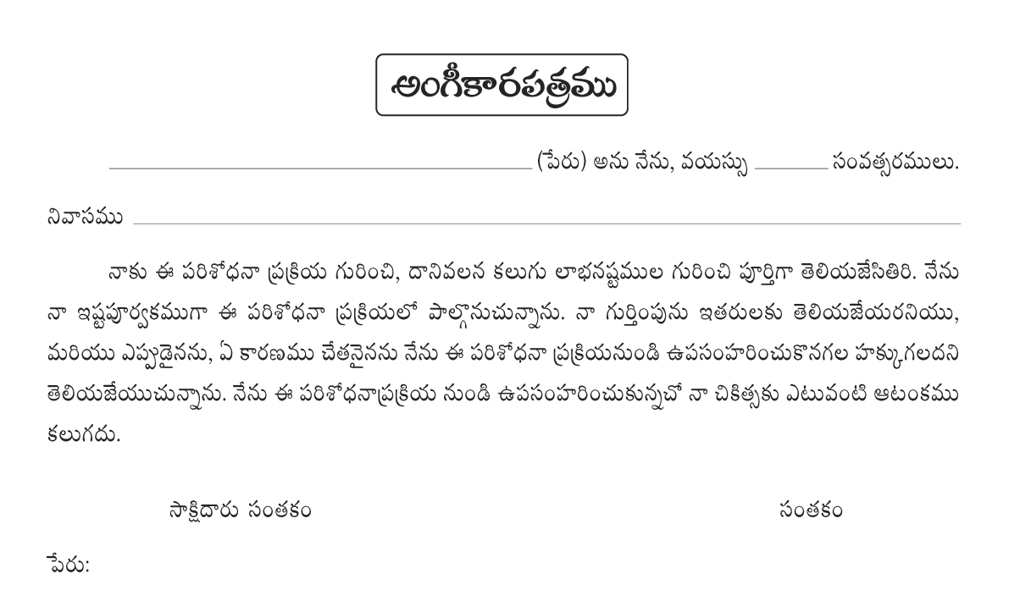

CASE RECORD FORM (CRF)
ID NO:

Title :
Principal investigator :
Department & Institution :

Demographic data:

Specific Study related information:

Measurements: (if any)

Investigations (if any):

Signature of the person collecting the data

